Section 1: Dataset Preparation and Transformation

The student successfully selects and uses the *Student Enrollment Statistics* sample topic in QuickSight.

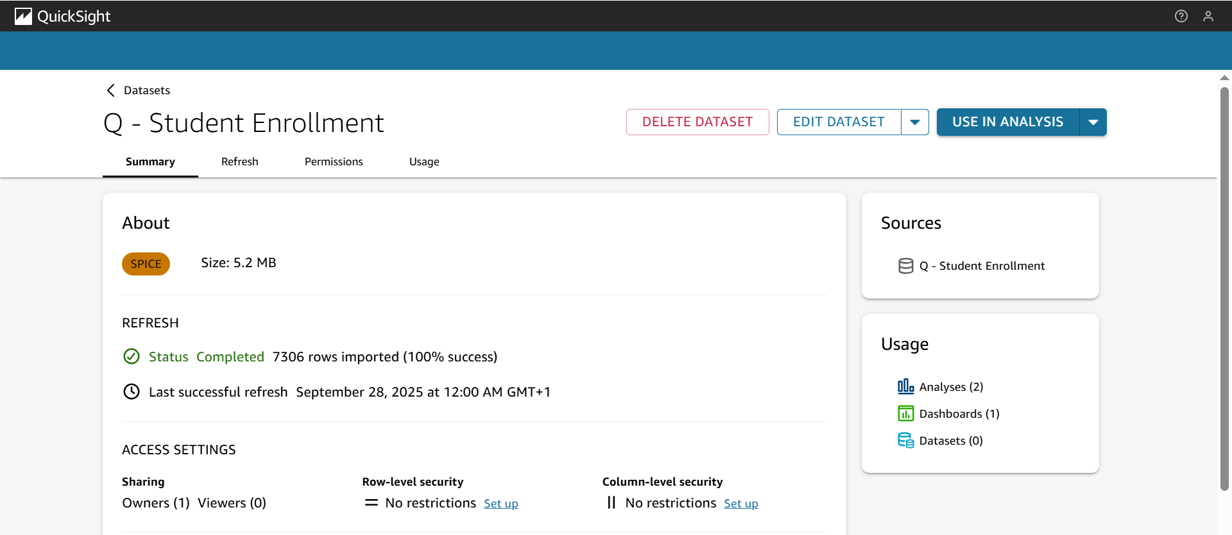

The Q - Student Enrollment dataset is visible and accessed in the Datasets section.

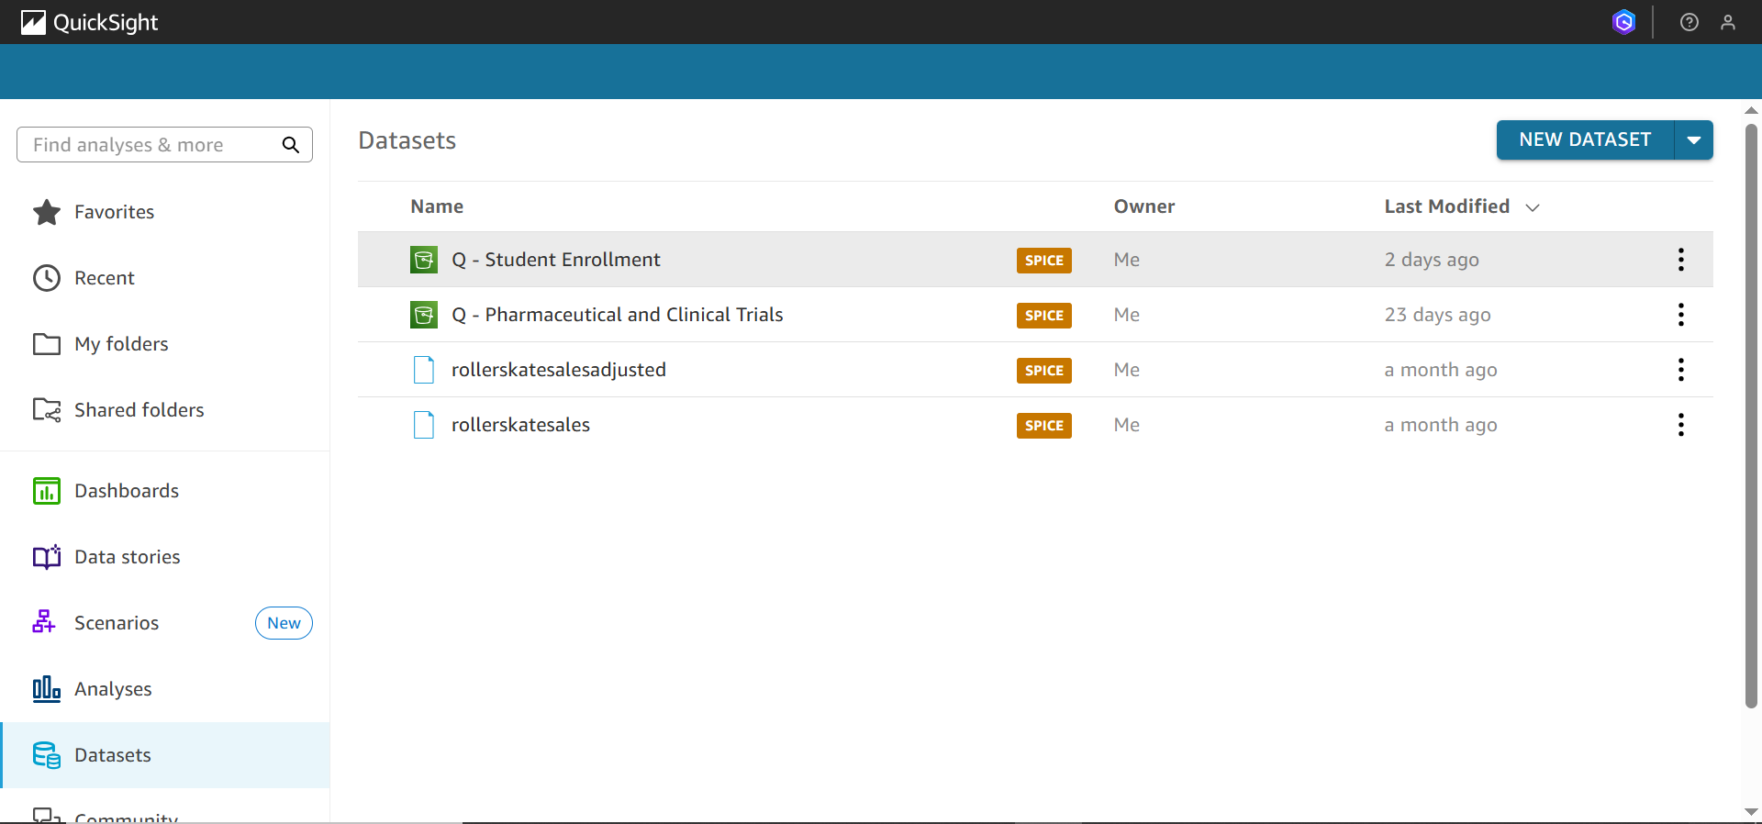

The dataset is scheduled to refresh weekly at 12:00 AM on Sunday in the student's local time zone.

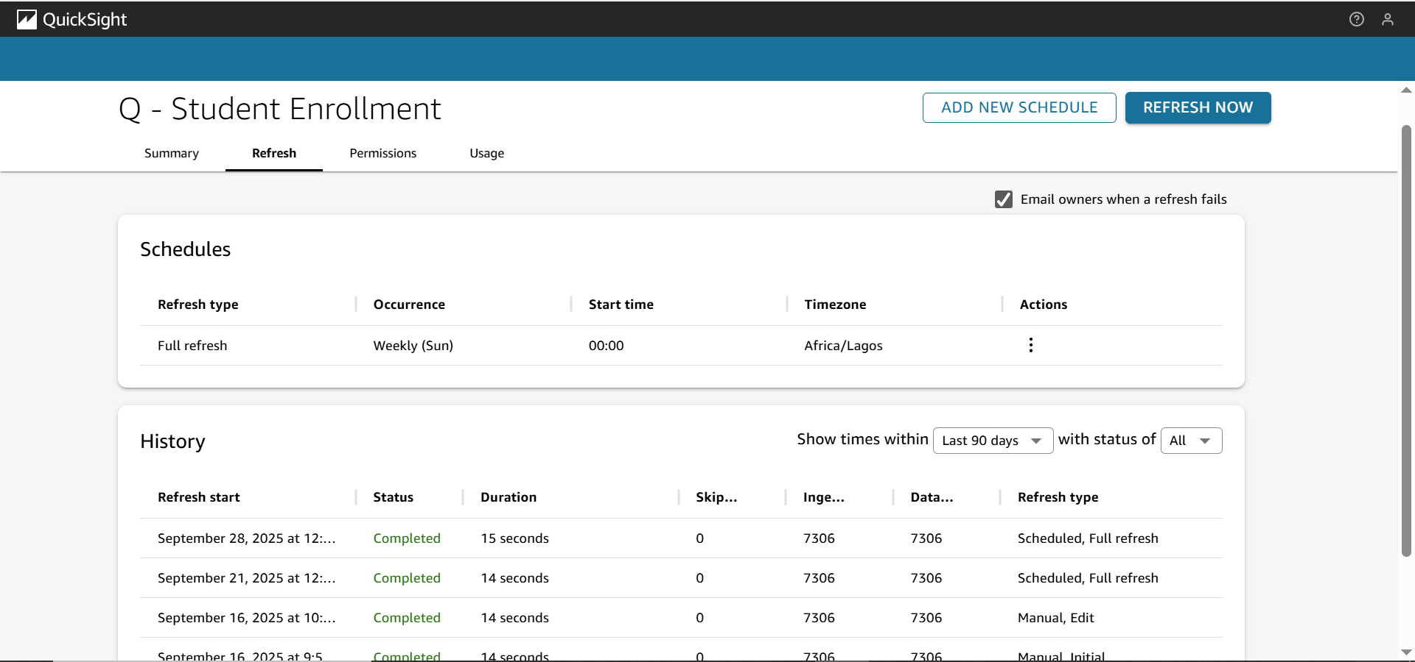

Field HomeOfOrigin is renamed to NationalOrigin with the provided description.

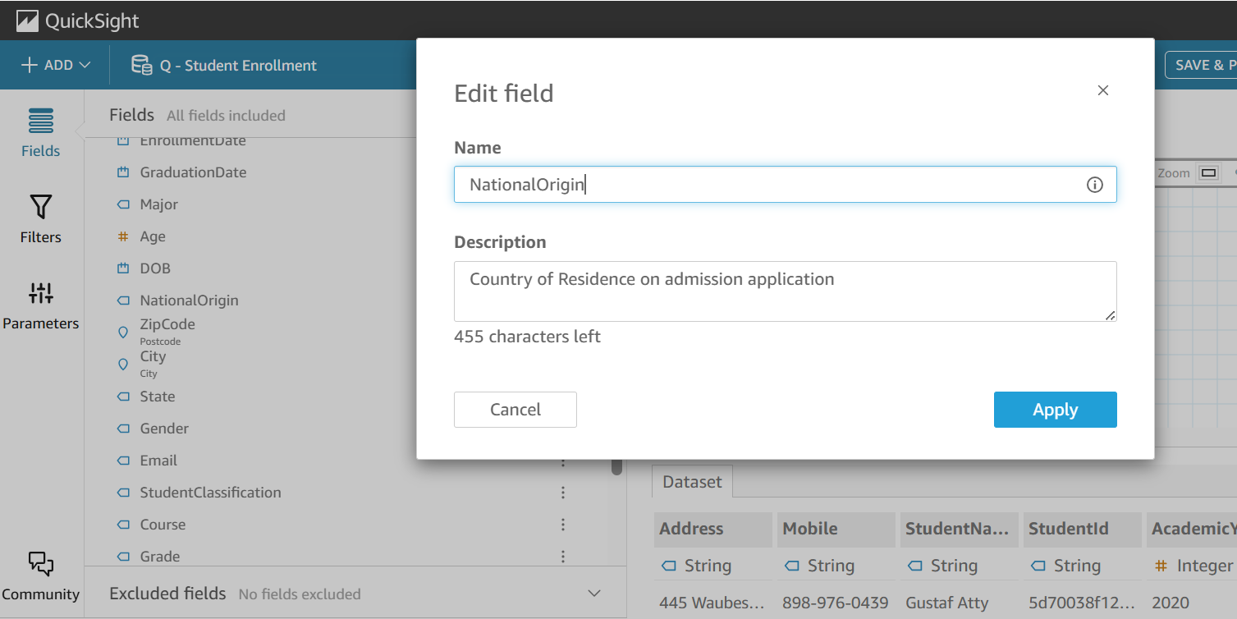

A calculated field Student Type is created with the formula ifelse({Age} < 30, "Youth", "Adult Continuing Education").

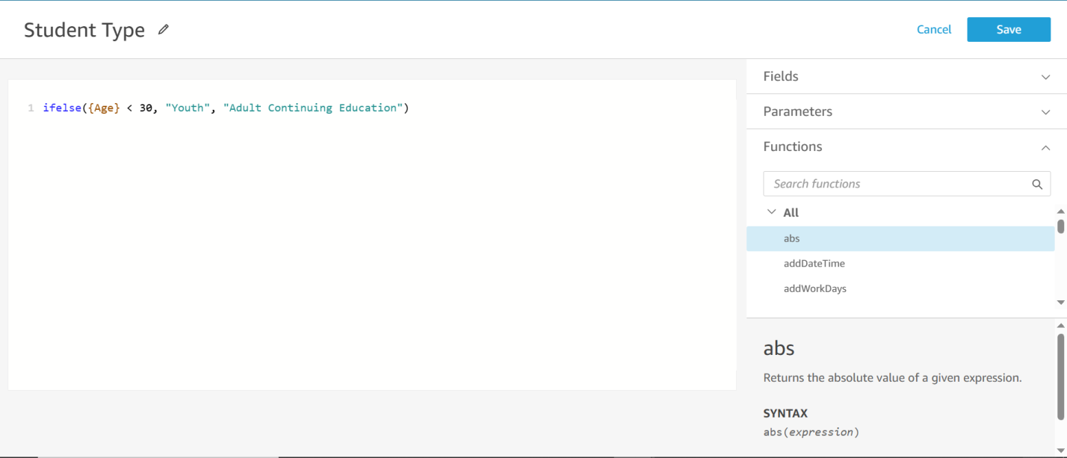

## Section 2: Creating Visuals Using Amazon Q

A visual is created from the prompt: “Show the number of students in each major, grouped by their academic year,” and is renamed to Student Majors by Year.

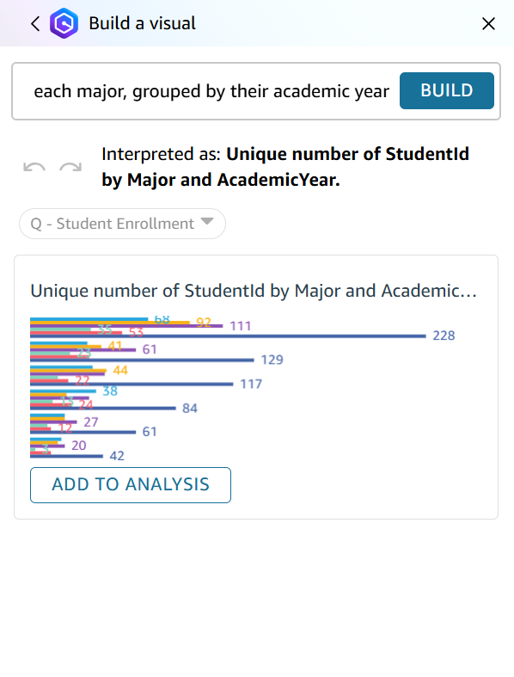

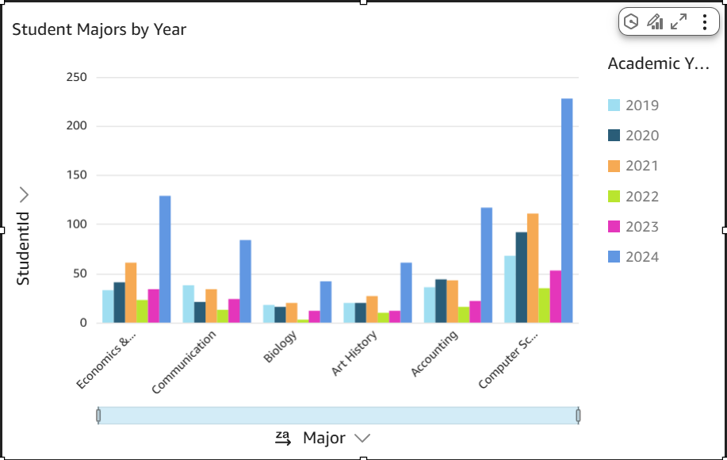

A pie chart is created from the prompt: “Pie chart of Student Types,” and is renamed to Proportion of Student Types.

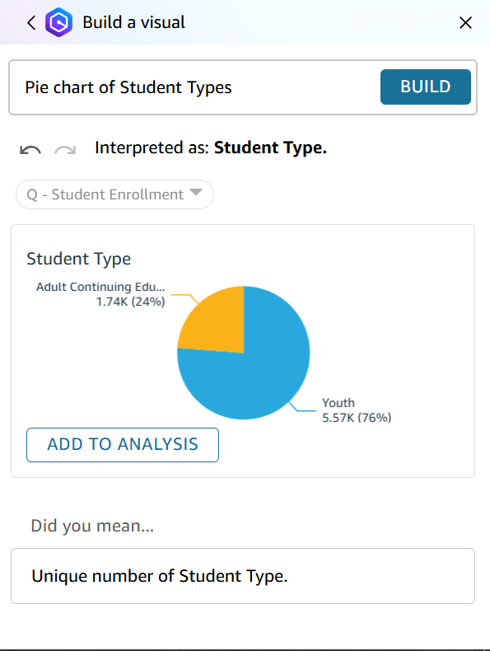

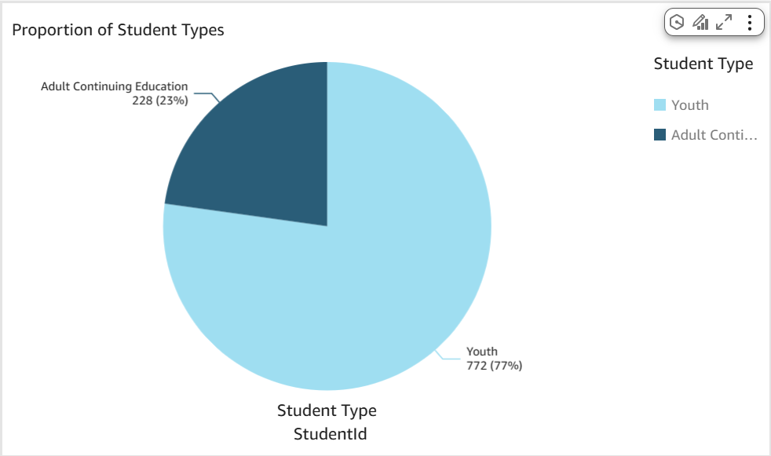

Visuals are appropriately resized and formatted (e.g., Academic Year formatted without commas).

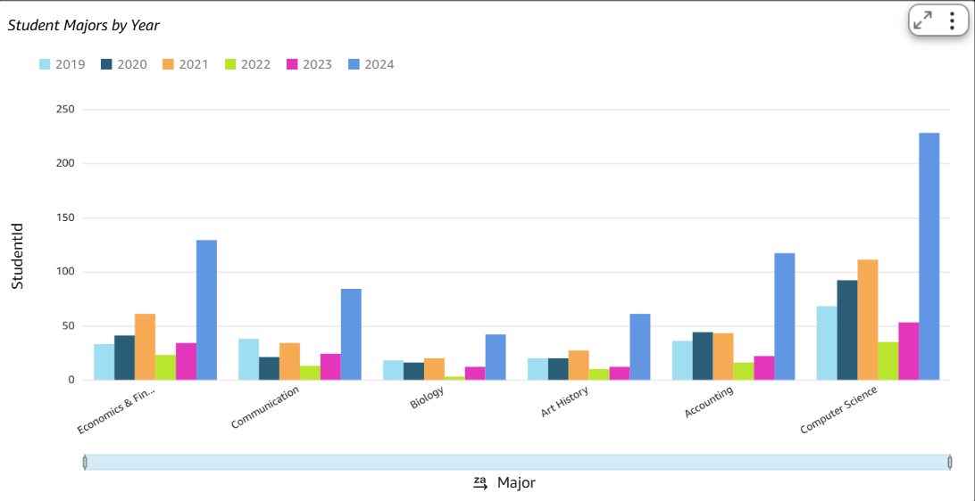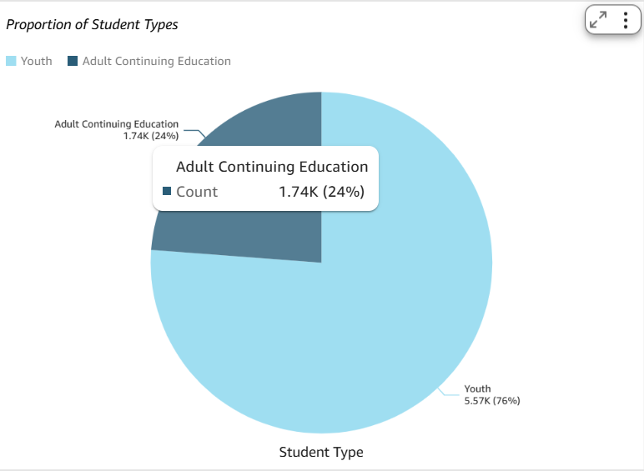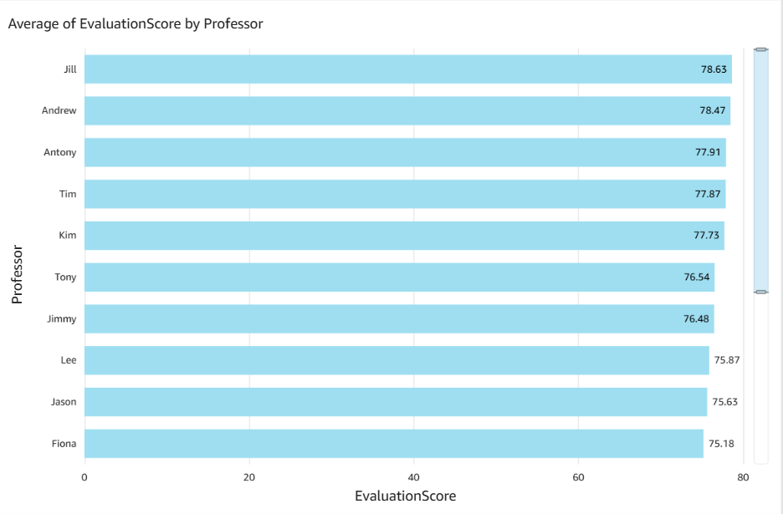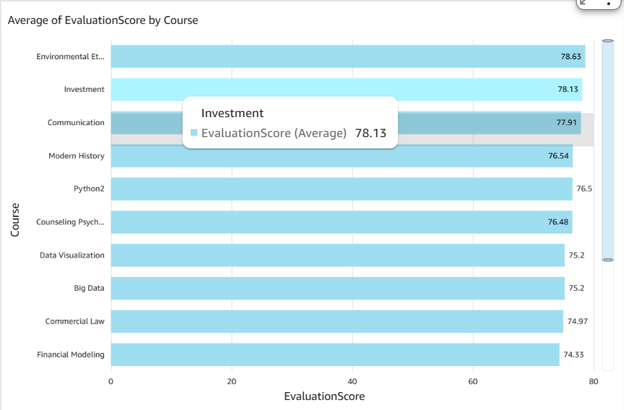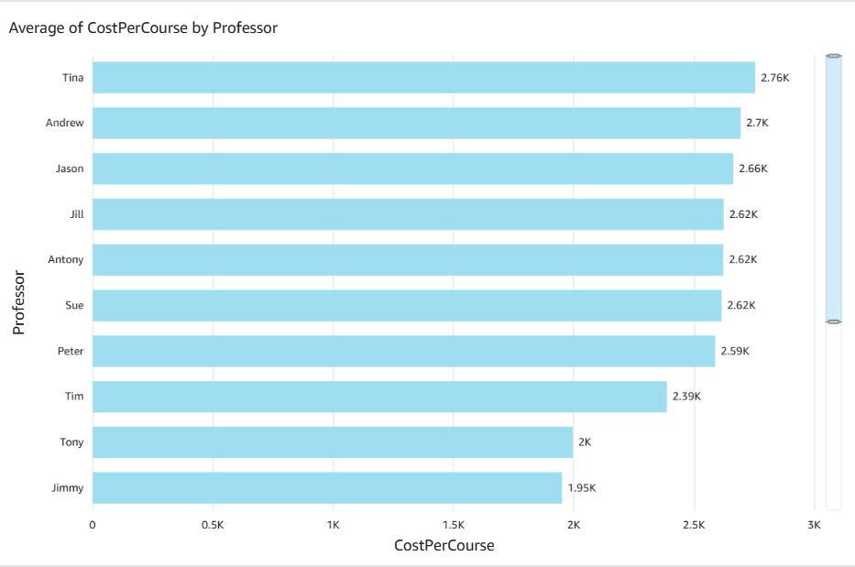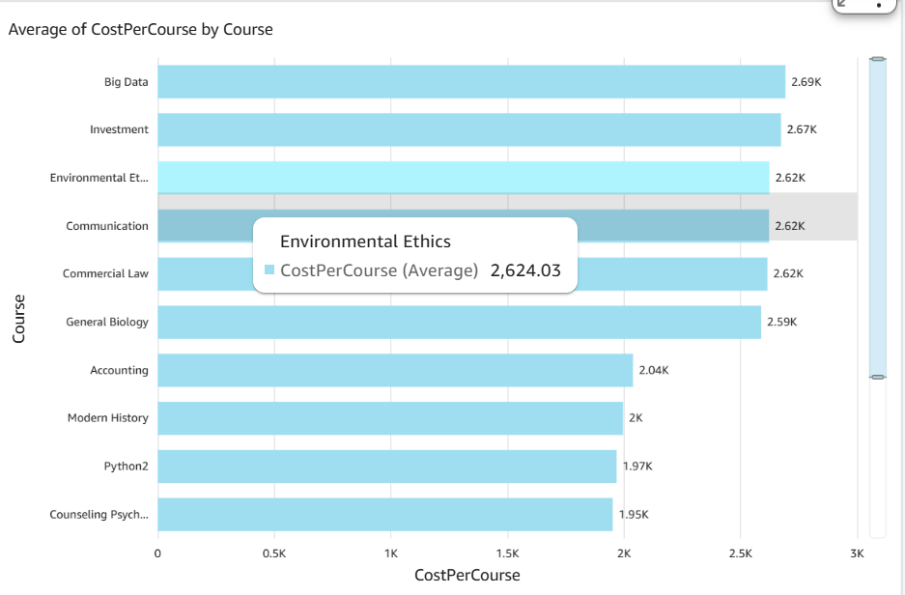

## Section 3: Building Interactive Dashboards and Topics

The dashboard is published and named Student Enrollment Dashboard.

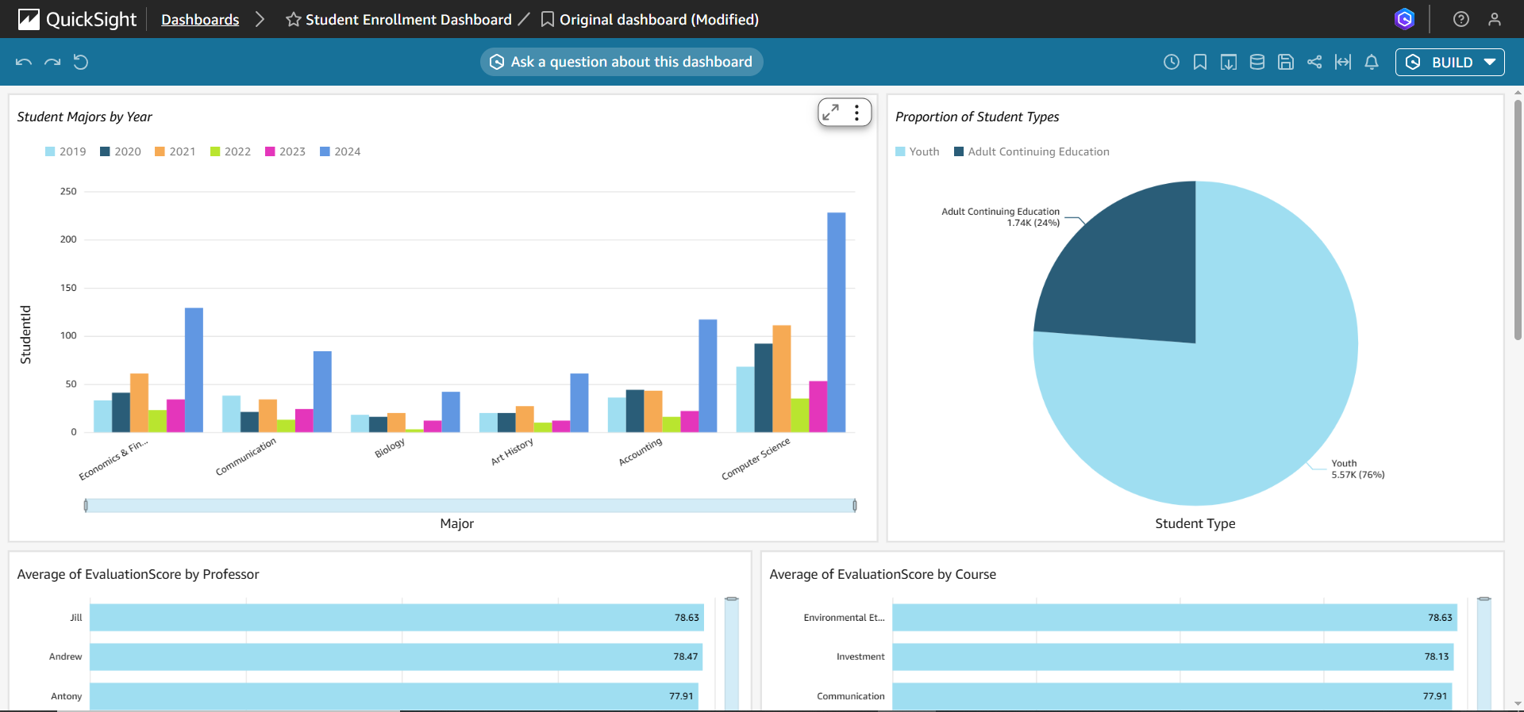

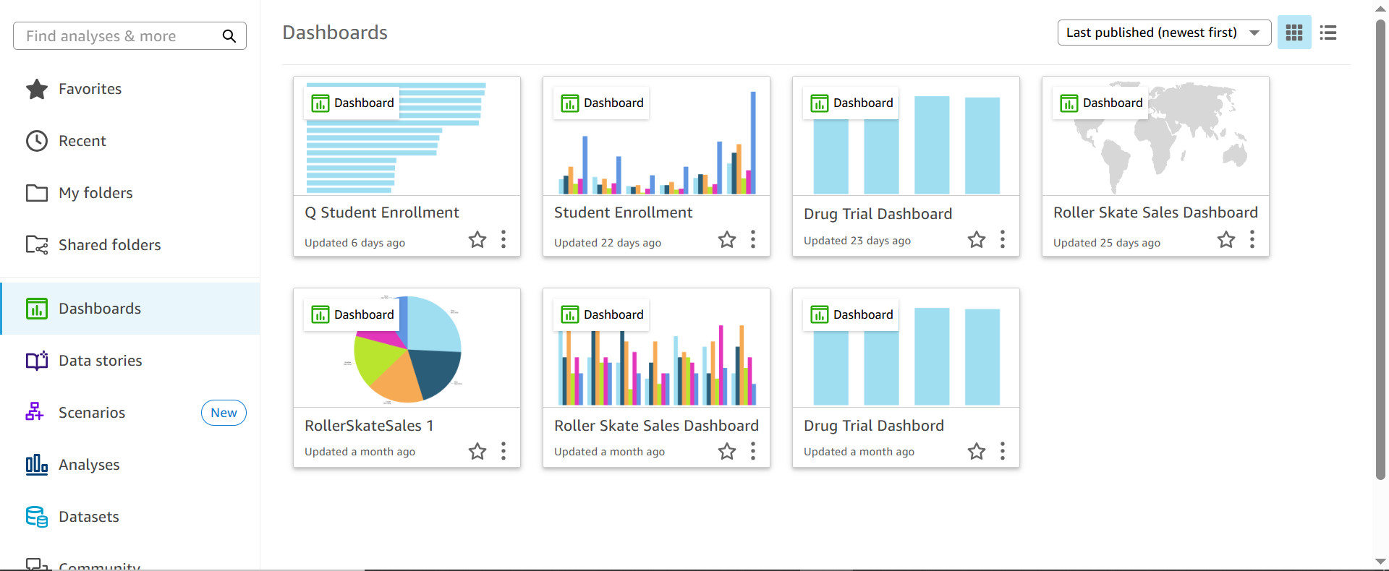

A custom topic named Regional Community College Student Data is created and linked to the Q - Student Enrollment dataset.

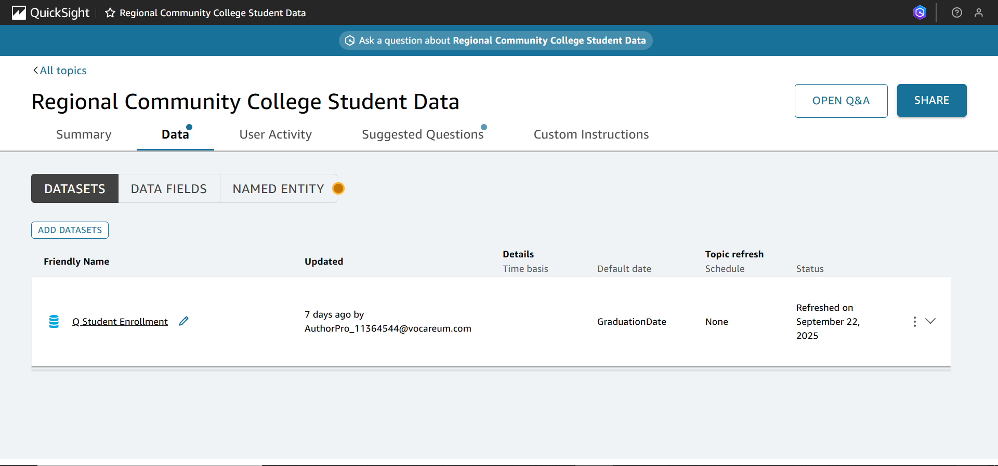

The topic includes all required fields as listed in the instructions.

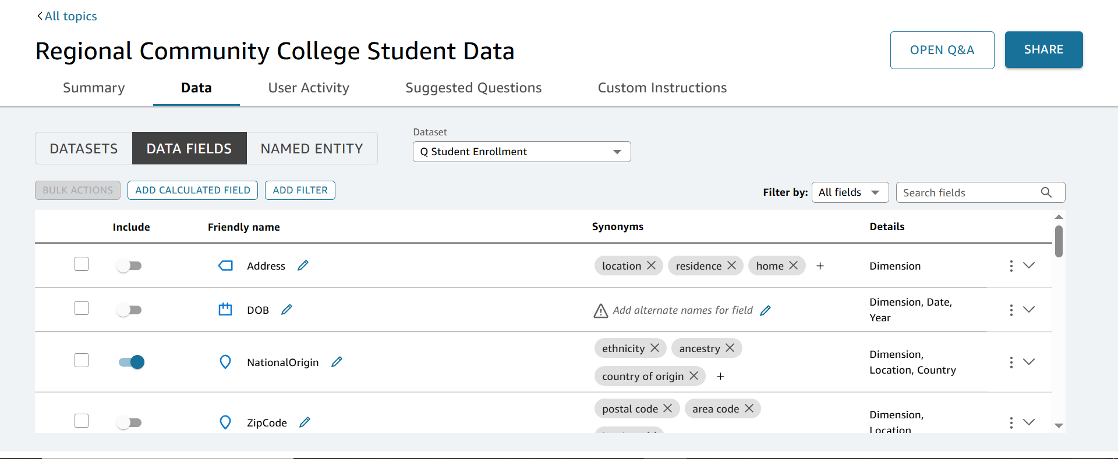

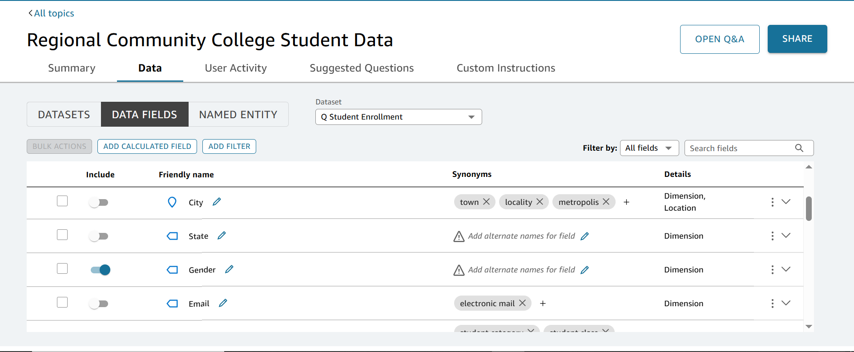

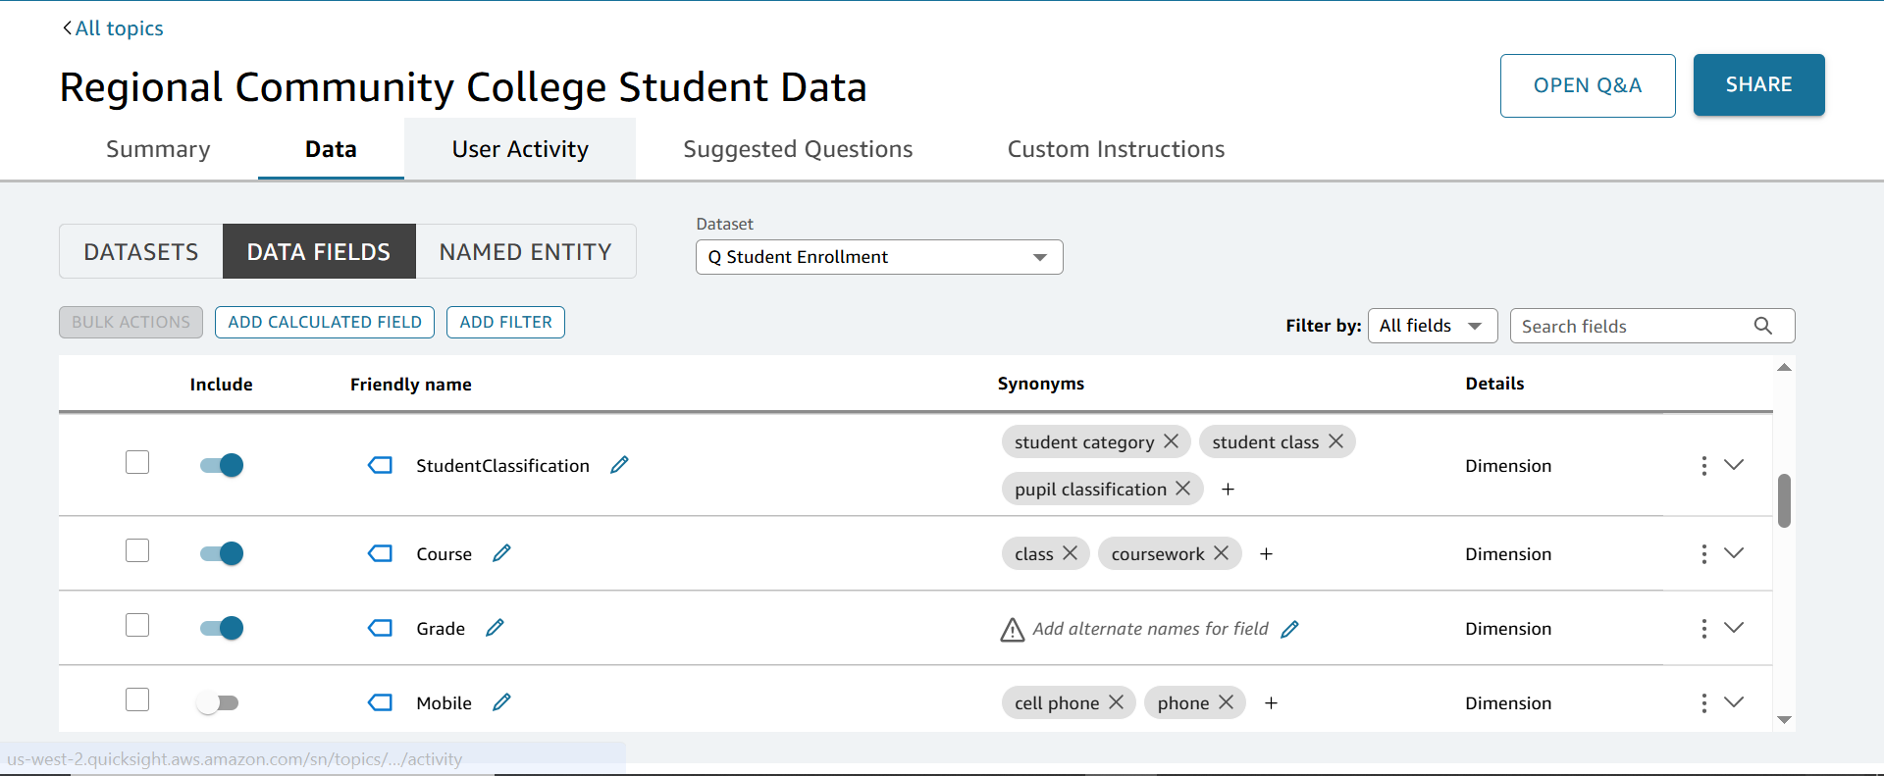

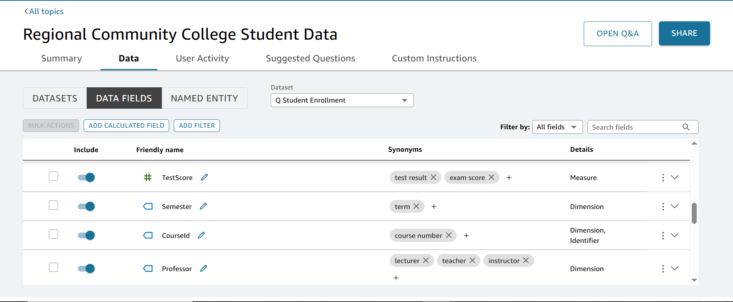

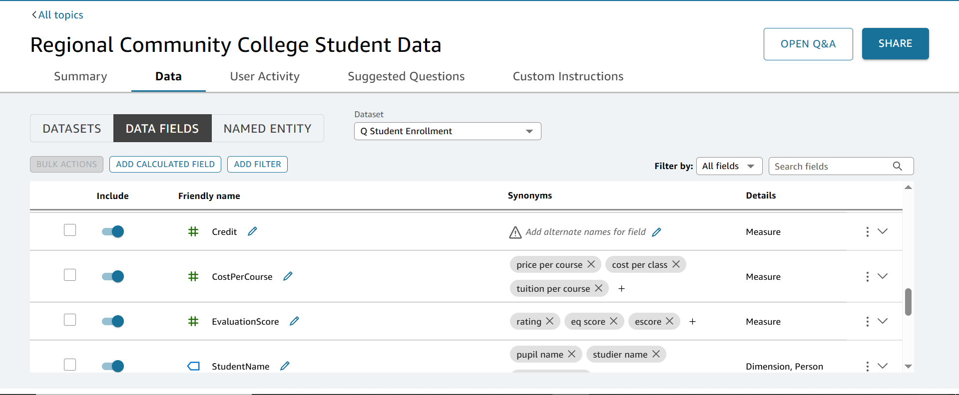

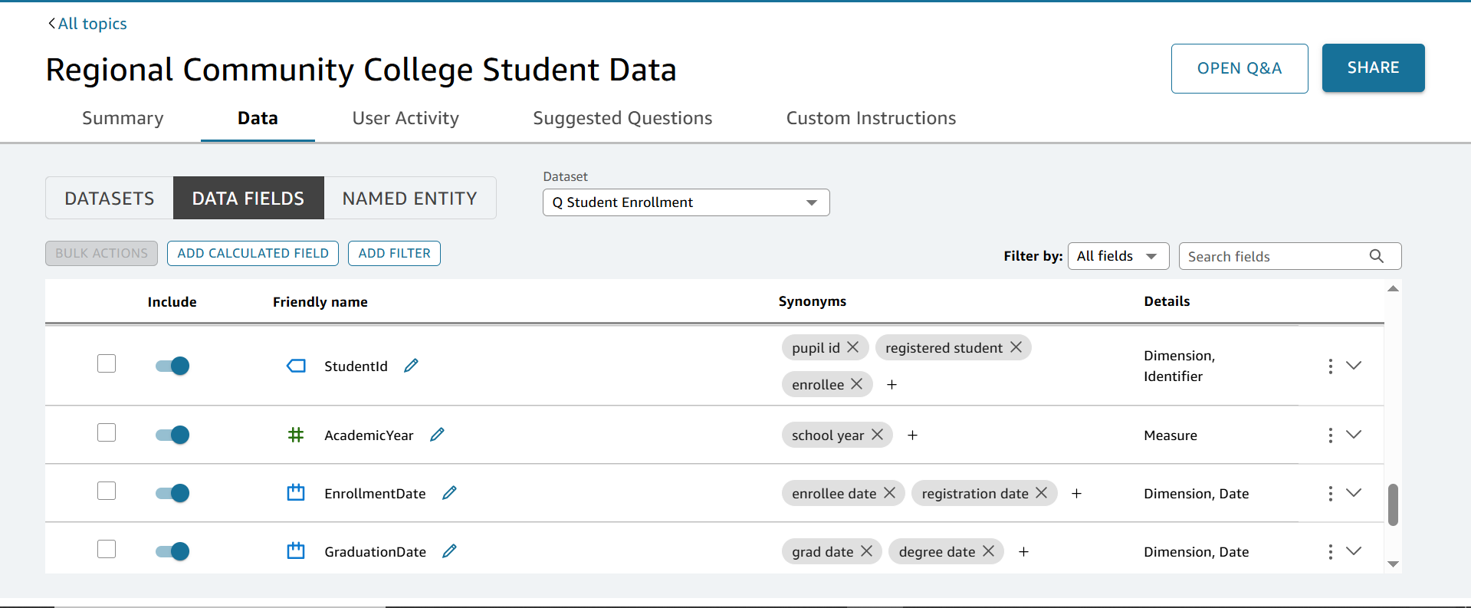

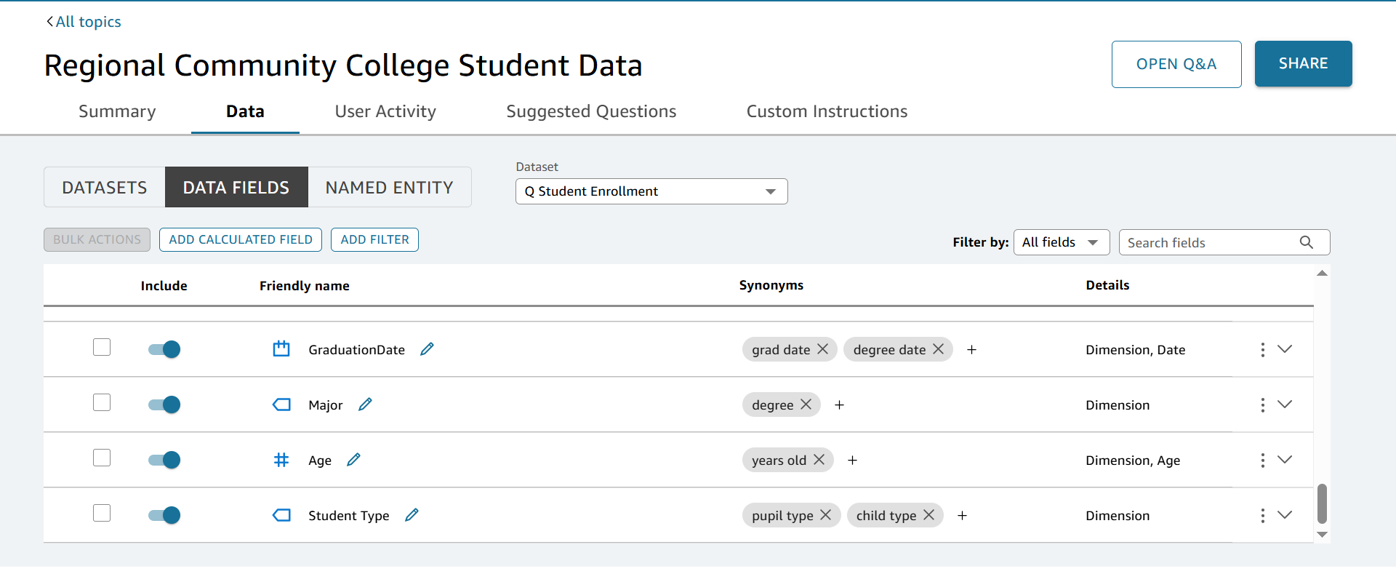

Three named entities are created:

* + Student Details
  + Course Details
  + Professor Evaluation

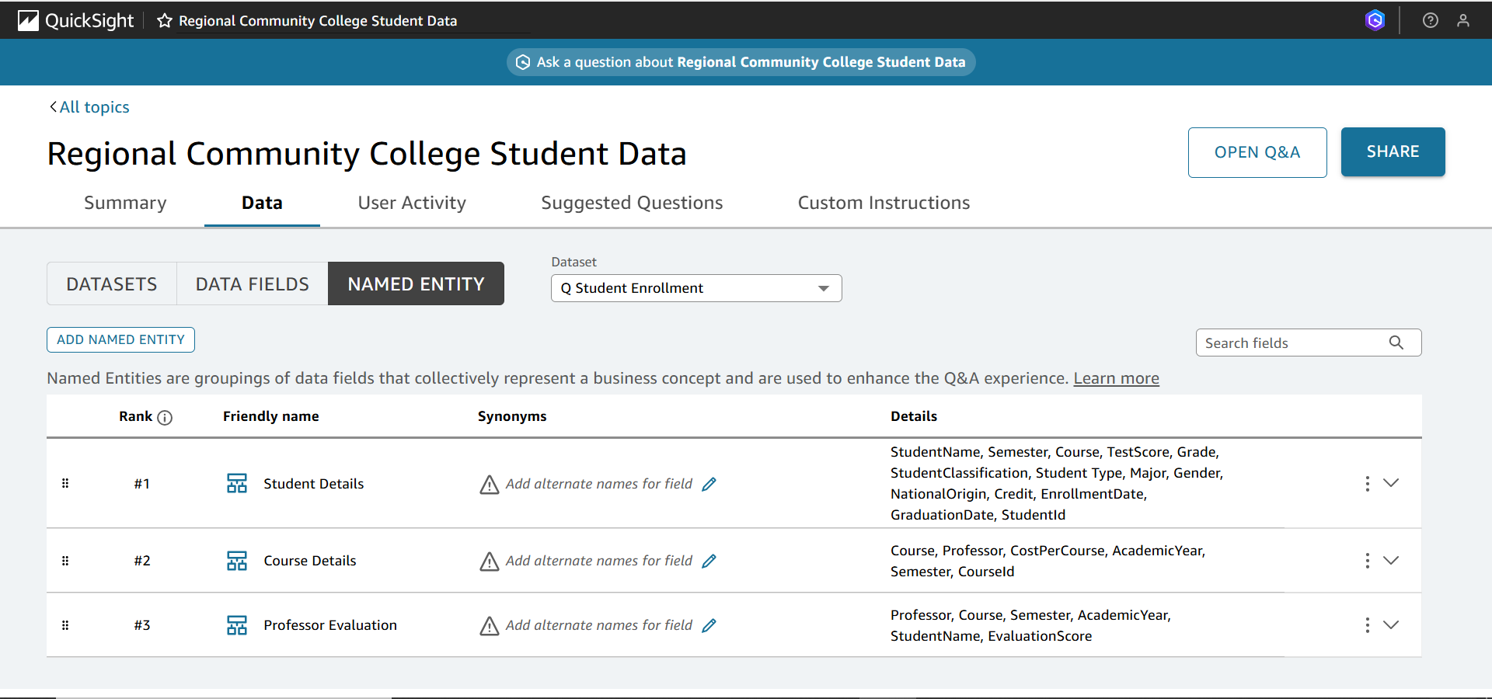

## Section 4: Scenario Creation and Complex Questioning

A Scenario titled Improving Student Satisfaction Without Increasing Costs is created using at least two visuals from the dashboard.

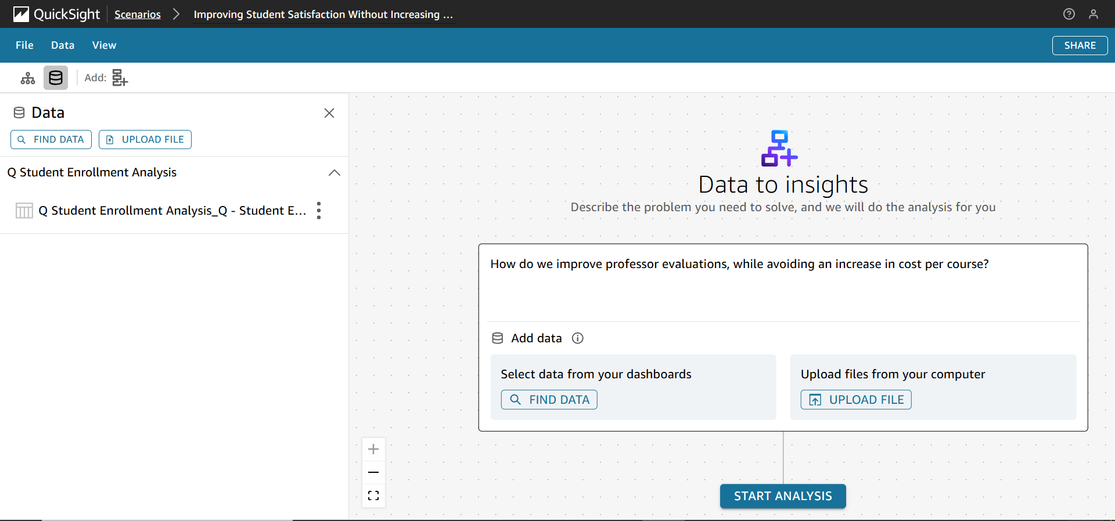

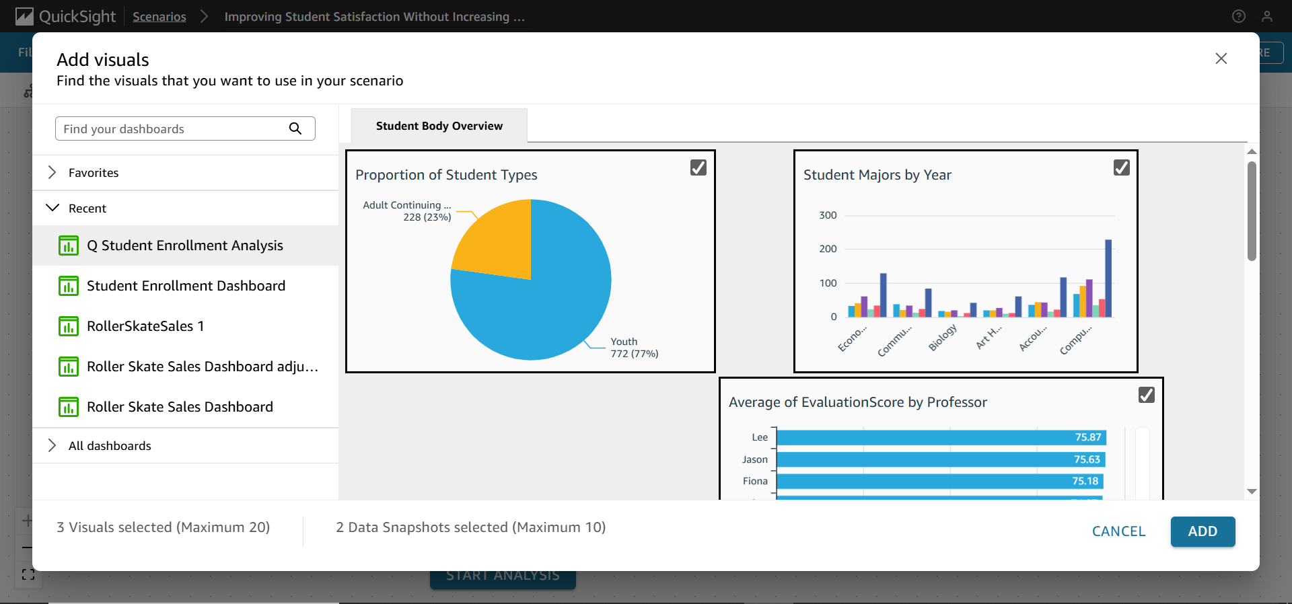

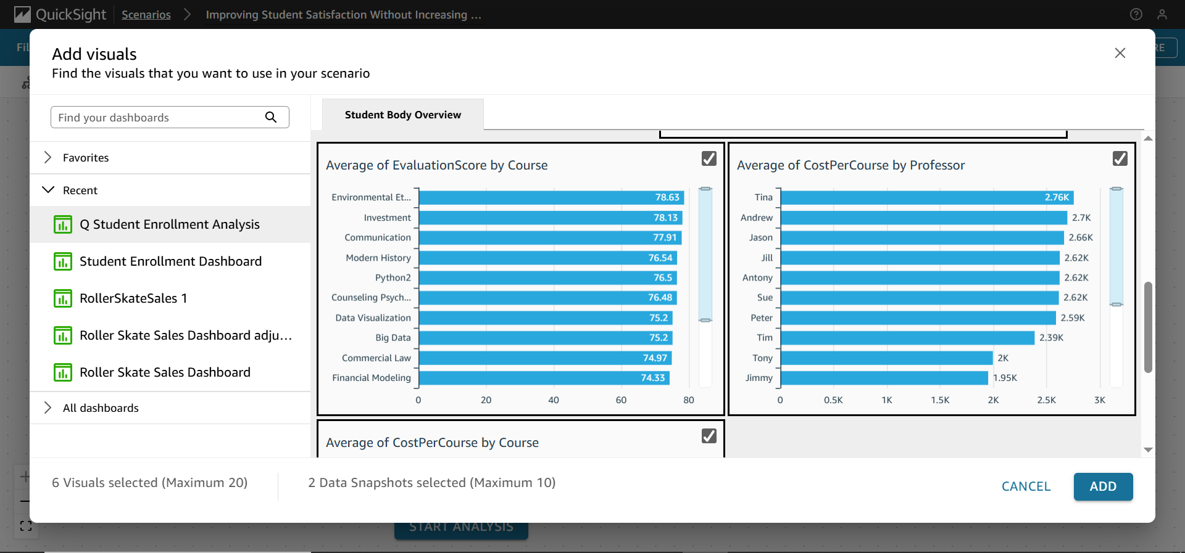

The student submits a complex, multi-part question: “How do we improve professor evaluations, while avoiding an increase in cost per course?”

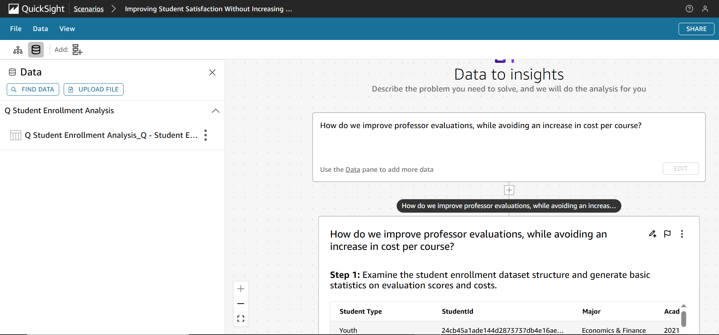

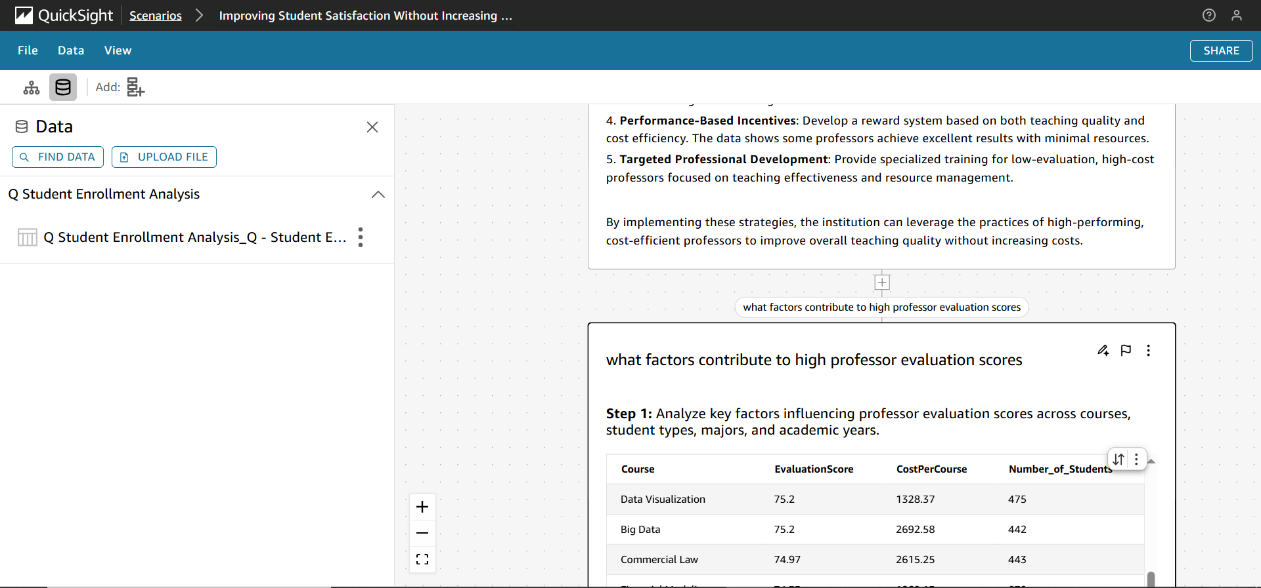

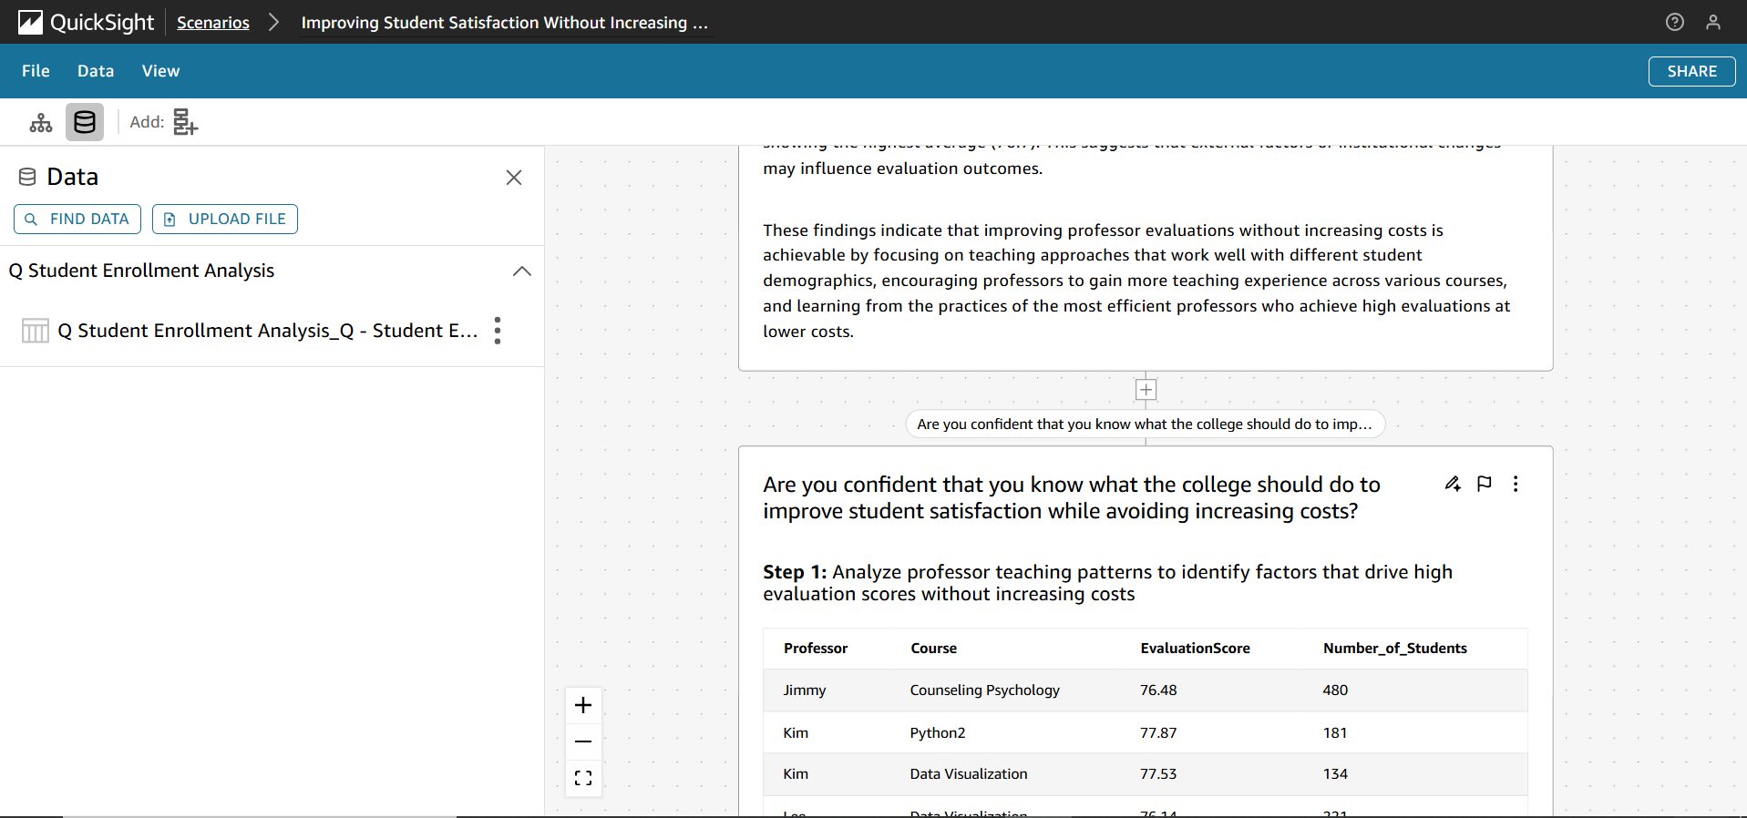

## Section 5: Data Storytelling

A data story is created with the prompt: “Create a data story that demonstrates that increasing class sizes in humanities courses would improve student satisfaction while minimizing additional course costs.”

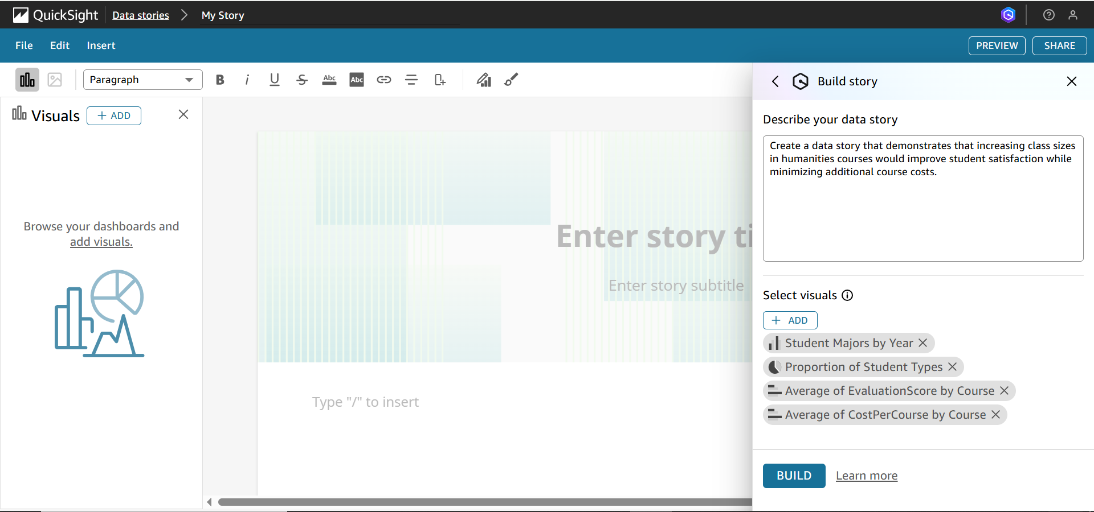

The visuals used include:

* + Student Majors by Year
  + Proportion of Student Types
  + Average of EvaluationScore by Course
  + Average of CostPerCourse by Course





The data story is styled with a pleasant layout and includes the student's name in the "Prepared by" section.

